**Tutorial problems - 1**

1. Find the domain and range of the function:
$$a) f\left(x\right)=9+\sqrt{3x+24} , b) g\left(x\right)=\frac{-9}{\sqrt{10-5x}}$$

2. Find the inverse of the function:
$$a) f\left(x\right)=\sqrt{5x-7}$$

$$b) f\left(x\right)=\frac{8x}{2x+3} , x≠-\frac{3}{2}$$

3. The point $A$ has coordinates $\left(-1;2\right)$ and the point $B$ has coordinates $\left(3;-5\right)$.

$a)$ Find the equation of the line $AB$, giving your answer in the form $ax+by+c=0$, where $a, b, c$ are integers.

$b)$ the midpoint of $AB$ is $M$. Find the coordinates of $M$. Write the equation of the line which passes through $M$ and which is perpendicular to $AB$.

1. Let $f\left(x\right)=x^{2}+3$ and $g\left(x\right)=x-2.$

$a)$ Find $(f∘g)\left(x\right)$.

$b)$ Write down the $y$-intercept and the coordinates of the vertex of the graph of $(f∘g)$.

1. A curve has equation $y=x^{2}+\left(3k-4\right)x+13$ and a line has equation

$y=2x+k$, where k is a constant.

$a)$ Show that the x-coordinate of any point of intersection of the line and curve satisfies the equation $x^{2}+3\left(k-2\right)x+13-k=0$.

$b)$ Given that the line and the curve do not intersect. Show that

$9k^{2}-32k-16<0$. Find the possible values of $k$.

1. Calculate the limits:

 

     

1. Given the function

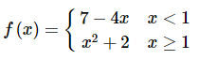

Evaluate the following limits, if they exist.



1. Given the function

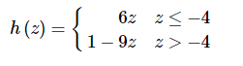

Evaluate the following limits, if they exist.



1. Find the values of the parameters a and b such that the function

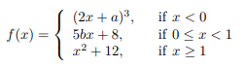

is continuous at all the points in its domain.

1. Sketch the graph of the function and determine the points of discontinuity for the function:
$$f\left(x\right)=\left\{\begin{aligned}&{-x}^{2}+3, x<0 \\ &3x-2, 0≤x<3 \\ &7 , x≥3 \end{aligned}\right.$$

2. Given

$y=\frac{1}{4}\tan{x}+\frac{1}{x^{2}} , 0<x≤2π$.

Solve the equation

$$\frac{dy}{dx}=1-\frac{2}{x^{3}}$$

1. Answer the following questions:

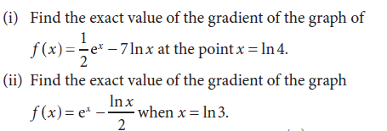

1. Write the equation of tangent line to the curve

$$y=e^{x}+2\sin{x}$$

at the point $x=\frac{π}{2}$.

1. Find the equation of normal to the curve $y={\left(x-2\right)}^{3}$ when $x=2$.
2. Let $f(x)$ be a cubic polynomial function. Given that $f\left(0\right)=2, f^{'}\left(0\right)=-3$,

$f\left(1\right)=f^{'}\left(1\right)$ and $f^{″}\left(-1\right)=6$. Find $f(x)$.

1. Differentiate the given functions:

$$a) f\left(x\right)=\left(x^{2}+1\right)e^{5x+2}$$

$$b) f\left(x\right)=\tan^{3}\left(π-7x\right)$$

$$c) f\left(x\right)={8x}^{3}\ln{x }- \frac{\cos{x}}{3x+7}$$